**Databases Assignment – Documentation**

**Public GIT (Github/Bitbucket/Gitlab) url:** [**https://github.com/nic227/Database-Assignment**](https://github.com/nic227/Database-Assignment)

**Public API (Vercel or otherwise) URL:** [**https://database-assignment-blue.vercel.app/docs**](https://database-assignment-blue.vercel.app/docs)

**Task 2: Screenshot/s of Mongo Database on MongoAtlas**

**Task 3A: Screenshot of the API running on localhost in your browser**

**Task 3B: Screenshot of the hosted API running on a public URL such as Vercel**

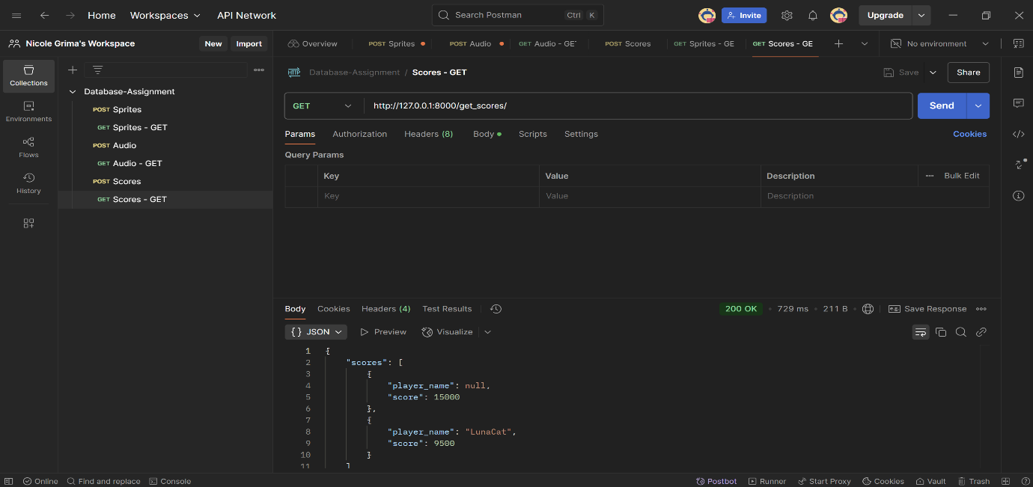**Task 4A: Screenshot showing credential setup**

**Task 4B: Screenshot showing IP Whitelisting**

**Task 4C: Screenshot showing how you are preventing SQL injection**

